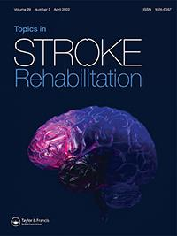

Topics in Stroke Rehabilitation

ISSN: (Print) (Online) Journal homepage: https://www.tandfonline.com/loi/ytsr20

Longitudinal changes of motor cortex function during motor recovery after stroke

Li Chunyong, Li Yingkai, Liu Fuda, Che Jiang & Yan Liu

To cite this article: Li Chunyong, Li Yingkai, Liu Fuda, Che Jiang & Yan Liu (2022): Longitudinal changes of motor cortex function during motor recovery after stroke, Topics in Stroke Rehabilitation, DOI: 10.1080/10749357.2022.2051829

To link to this article: https://doi.org/10.1080/10749357.2022.2051829


Published online: 20 Mar 2022.


Submit your article to this journal 
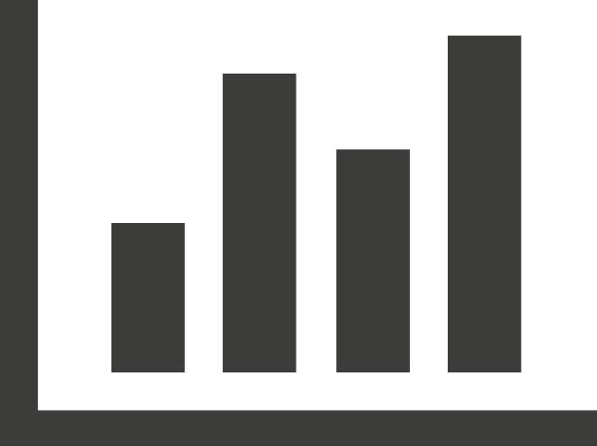

Article views: 79


View related articles


View Crossmark data

Full Terms & Conditions of access and use can be found at

https://www.tandfonline.com/action/journalInformation?journalCode=ytsr20


TOPICS IN STROKE REHABILITATION

https://doi.org/10.1080/10749357.2022.2051829


Longitudinal changes of motor cortex function during motor recovery after stroke

Li Chunyongª, Li Yingkai^{b}, Liu Fuda^{c}, Che Jiang^{d}, and Yan Liu^{e}

ªDepartment Encephalopathy, Guangzhou Conghua District Hospital of Traditional Chinese Medicine, Guangzhou, Guangdong, China;

^{b}Department. Neurology, The First Affiliated Hospital of Sun Yat-sen University, Guangzhou, Guangdong, China; ^{c}Area 2, Department of Neurology, Jiangmen Central Hospital, Beijie, Jiangmen City, Guangdong, China; ^{d}Department of neurosurgery, General Hospital of Southern Theatre Command, PLA, Guangzhou, Yuexiu District, China; ^{e}Department Neurology, Foresea Life Insurance Guangzhou General Hospital, Guangzhou, Guangdong, China

ABSTRACT

Background and purpose: Functional magnetic resonance imaging (fMRI) combined with beha-vioral assessments was used in our study to investigate the dynamic process of motor cortical functional reorganization after infarction. Therefore, we could provide a theoretical basis and build a useful evaluation system for rehabilitation after stroke and various other cerebral injuries.

Methods: Acute stroke patients with a single lesion in the middle cerebral artery supply area and age- and sex-matched healthy volunteers were recruited. A longitudinal observational study invol-ving 20 patients with stroke was conducted using repeated fMRI. Task-based fMRI data were acquired 3 times over a period of 3 months. The behavioral assessment included dynamometer and finger-tapping tests to evaluate the strength and dexterity of each upper arm.

Results: Behavioral results: The behavioral assessments demonstrated large improvements in session 2 and session 3. fMRI results: The healthy group showed activation in the contralateral primary sensory-motor cortex (S1M1) when executing tasks with either the left or right hand. Compared with the healthy subjects, the patients demonstrated greater activation in the ipsilateral frontal and parietal cortices and supplementary motor areas (SMAs). Across all sessions, more motor activation was observed in the left infarction group.

Conclusions: Our results show that motor cortical activation induced by moving the paretic hand changes over time. There were differences in motor functional recovery and motor cortex com-pensation between the dominant hemisphere and nondominant hemisphere after stroke.

ARTICLE HISTORY

Received 18 June 2021 Accepted 5 March 2022

KEYWORDS

fMRI; motor cortex; reorganization; stroke; rehabilitation; BOLD

1. Introduction

Stroke has the highest morbidity and mortality rates in the developed world. Most patients have different degrees of brain dysfunction; approxi-mately 65%~80% of stroke patients experience dyskinesia.¹ Neuroplasticity includes changes in the structure and function of the central nervous system after injury and changes in “activity” modification.² Neuroplasticity plays an important role in the recovery of nerve function after stroke and can compensate for the loss of motor function after stroke. Many studies involving human and animal models have shown that the central nervous system promotes motor recovery after brain injury through brain functional reorganization, which is not only limited to the preserved region of the

injured hemisphere but also occurs in the isotonic region of the intact hemisphere.³ Brain plasticity can occur spontaneously after brain injury, and rehabilitation training can modify and promote this neuroplasticity process.⁴

The mechanisms of cortical function reorganiza-tion involve the reorganization of periinfarct tis-sues, the recruitment of the ipsilesional or contralesional cortex, changes in interhemispheric interactions or bihemispheric connections, and the regulation of synaptic fuction.⁵ However, at differ-ent stages after stroke, there is complex coactivation of the normal cortex and the focal cortex. For example, studies have shown that the correspond-ing area in the contralateral cortex frequently shows coactivation during the recovery stage of stroke, but

CONTACT Yan Liu 13060812626@163.com Department of Neurology, Foresea Life Insurance Guangzhou General Hospital, No. 703, Xincheng Avenue, Guangzhou, 511340, PR China

*(Chunyong Li and Yingkai Li contributed equally to this study.)
This article has been corrected with minor changes. These changes do not impact the academic content of the article.

© 2022 Taylor & Francis Group, LLC

2  L. CHUNYONG ET AL.

plasticity in the contralateral hemisphere does not promote the functional recovery of injured limbs in stroke survivors. Cortical activation surrounding ipsilateral lesions is associated with improved func-tional recovery, especially during the acute phase.⁶

Previous studies have found that cortical activation changes dynamically over time after brain injury.⁶ However, we also found limitations in these studies. First, these studies enrolled too few patients. Second, these studies did not strictly control the enrollment conditions such that some stroke patients were in the acute stage while other patients were in the subacute or chronic stages. Third, the task design in some studies was inconsistent. Finally, none of these stu-dies focused on the differences in reorganization between the dominant hemisphere and nondomi-nant hemisphere after cerebral stroke. Therefore, in our study, we strictly controlled the enrollment cri-teria, recruited more patients and used the same task throughout the entire process. Most importantly, we compared the differential characteristics between dominant hemisphere and nondominant hemisphere motor cortex compensation after stroke

2. Methods

2.1. Participant inclusion criteria

In total, 23 patients who had their first-ever stroke were assessed for eligibility. The inclusion criteria were as follows: (1) acute phase (1 day-4 days) from the onset of ischemic stroke; (2) unilateral
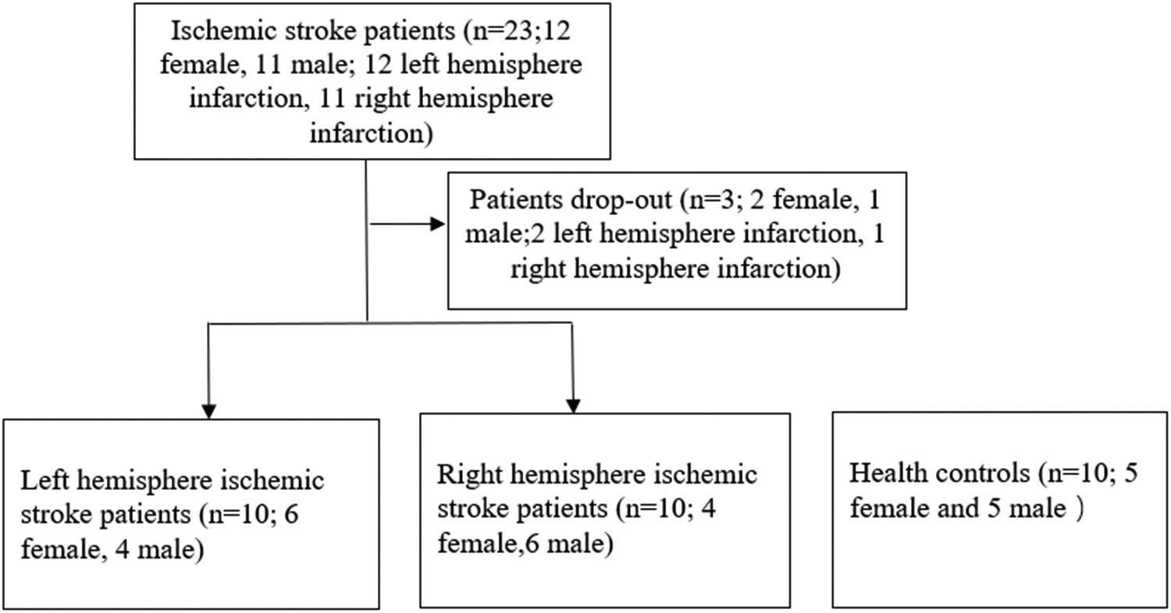

middle cerebral artery territory (including the basal ganglia, internal capsule, and corona radiata) lesions;
- mild-to-moderate motor deficits in the contrale-sional upper extremities, and Brunnstrom stage ran-ging from stage II to Stage V; (4) an age between 18 years and 80 years; and (5) right handedness as assessed by the Edinburgh Handedness Questionnaire. Subjects were excluded from the study if they had neurological disease, brain trauma disease history, personal or family history of seizure and psychological disorder, regularly used neuroac-tive substances, or performed professional work involving playing pianos and keyboards. Subjects were also excluded if they had other major organic diseases, a Mini-Mental State Examination score

<27, a Hamilton Depression Scale score <8, a Hamilton Anxiety Scale score <6, or contraindica-tions for fMRI, or refused or failed to cooperate during examinations. Two patients had another stroke, and one patient died of heart disease during the follow-up period. Finally, 20 patients with ischemic stroke (10 males and 10 females) completed the longitudinal fMRI experiments, and their ima-ging data were included in the analysis. Additionally, 10 healthy subjects (5 males and 5 females) were included as an age-matched control group (Figure 1). The inclusion criteria were as follows:

- an age between 18 and 80 years, and (2) right-handed as assessed by the Edinburgh Handedness Questionnaire. Volunteers with any of the following situations were excluded: (1) previous history of central nervous system and nonnervous system

Figure 1. Schematic diagram of the screening process.

diseases that affected the motor functions of extre-mities, (2) inability to cooperate during examina-tions, or (3) contraindications to MRI scanning. The experiments were conducted with the under-standing and written consent of each participant, and ethical approval was provided by the institu-tional review board.

2.2. Study design

The patients were divided into the following two groups based on their cerebral infarction lesion: group A was the left hemisphere infarction group, and group B was the right hemisphere infarction group. All patients were assessed in three different sessions (T1, 3 days after the onset of the complaint; T2, 30 days after the onset of the complaint; and T3, 90 days after the onset of the complaint) with both clinical assessments and fMRI scans (Figure 2). The clin-ical assessment included a dynamometer and finger-tapping test to evaluate the power of grip-ping and dexterity of each upper extremity. The patients were also evaluated with the upper extremity Fugl-Meyer-Assessment (UE-FMA) in three different sessions. The fMRI data were obtained during a positive finger flexion–exten-sion task.

TOPICS IN STROKE REHABILITATION | 3

2.3. Behavioral assessment

The power of gripping and dexterity of the upper extremities of each subject were assessed using grip strength and finger-tapping tests, respectively. The finger-tapping test measured the number of times the subjects were able to tap a computer key within 10 seconds using their index fingers,⁷ while a hand dynamometer was used to measure the maximal grip strength of the hands in units of kg.

2.4. Task design and image acquisition during fMRI

The patients were examined during three fMRI sessions while performing an active finger flexion– extension task that required the patients to clench the affected hand into a fist without the help of others; fMRI sessions were performed during each of the follow-up visits within a three-month period.

A block design was used in this fMRI trial. Following a 20-s rest period (one rest block), active movements of the affected hand were performed for 20 seconds (one movement block). In total, five blocks of active movement and five blocks of rest were performed during a single scanning session. The active movements were performed at 1 Hz following a visual system controlled by a computer system. The subjects were instructed to close their eyes throughout the rest period. Twenty healthy controls were scanned in only one
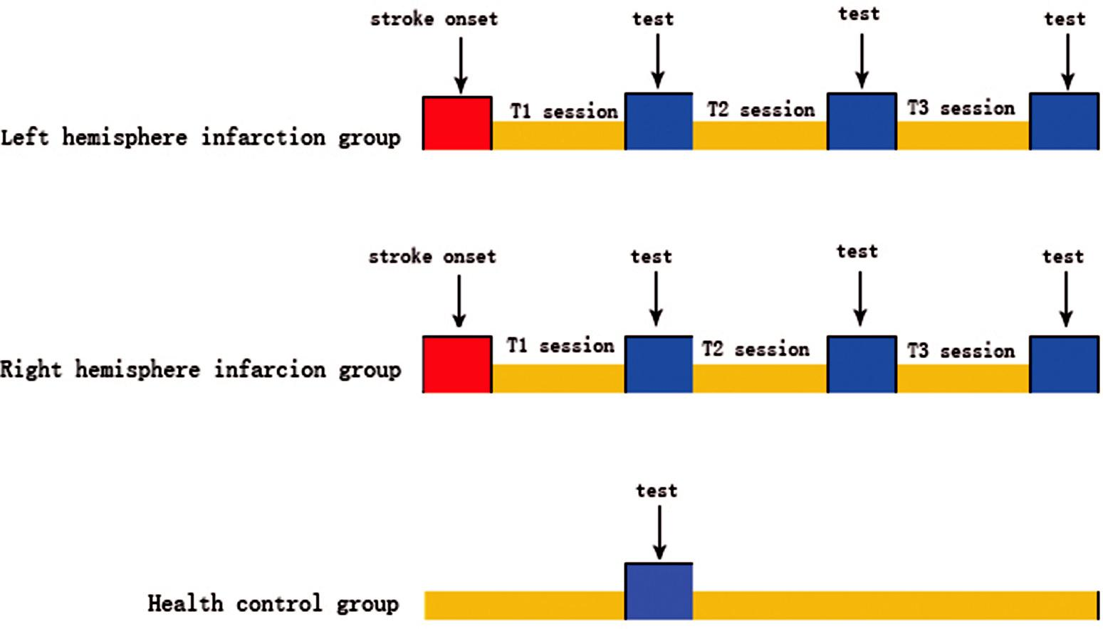

Figure 2. Flow chart of the experimental design.

4 L. CHUNYONG ET AL.

session while performing the same task with their left hands and right hands. No mirror movements (associated contralateral hand movements) or syn-kinesia (associated ipsilateral shoulder or elbow movements) were observed in any patient.

A Siemens Sonata 1.5 T superconductive mag-netic resonance imaging system (Siemens Vision, Erlangen, Germany) was used with a gradient field of 40 mT/m and a slew rate of 220 mT/m/ms. Blood oxygen level-dependent (BOLD) signals were col-lected from the subjects during both the movement and rest phases using an echo planar imaging (EPI) sequence with the following parameters: repetition time (TR): 2000 ms; echo time (TE): 49 ms; field of view (FOV): 210 mm; matrix: 64 × 64; slice thick-ness: 4 mm; slice gap: 1 mm; and number of slices: 28.

2.5. Statistical analyses

2.5.1 Statistical analyses of motor behaviors

IBM SPSS Statistics 23.0 software was used for the statistical analyses. The data obtained from the beha-vioral tests were statistically described as the means

- standard deviations. The normality of the distribu-tion and equality of variance were checked using the Shapiro–Wilk method and Levene’s test before the statistical inference testing. The statistics comparing the behavioral results between the groups were tested by using two-sample t-tests, and the change statistics within the same group were tested by using a repeated-measures ANOVA. Tukey’s test was used for the pairwise comparisons after the ANOVA. p < .05 was considered indicative of a statistically significant difference.

2.5.2 Statistical analyses of fMRI images

Statistical parametric mapping 8 (SPM8) soft-ware under the MATLAB platform was used to analyze the fMRI data of the subjects. For the individual analyses, the first 10 images of each sequence were removed to exclude any influence of the increase in the intensity of the magnetic field. Preprocessing included adjustments for head movements, spatial normalization, and spa-tial smoothing. The EPI image for each temporal sequence was rearranged behind the first

functional image to exclude any residual head movement. Subsequently, the functional images of each individual and each temporal sequence were rearranged with the first functional image of a standard model, and the size was readjusted to standardize the anatomical space for the group analyses. This standard anatomical space was presented as a MiNi coordinate graph. Finally, the images underwent Gaussian smoothing. Based on the testing tasks, the data from each subject were analyzed by deconvolution and a multiple linear regression of the F value of each voxel. The F values are presented as differ-ent colors and were projected onto the three-dimensional structure images to generate a statistical parameter map with thresholds of p < .05 (familywise error; FWR) and Ke≥10. Single-sample t-tests were used in the intragroup analysis to obtain the activation map in each group for all testing tasks using the same thresh-olds of p < .05 (FWR) and Ke ≥ 10.

2.6. STROBE Guidelines

This manuscript conforms to the STROBE guidelines (“Strengthening the Reporting of Observational Studies in Epidemiology”).

3. Results

3.1. Clinical statistics

We found no significant differences in age, days poststroke, or lesion volume between the left hemi-sphere stroke group and the right hemisphere stroke group (Table 1).

3.1.1 Finger-tapping test

The improvements in the average number of taps by the right hand in the left hemisphere stroke group (group A) between session 1 and session 2 and between session 2 and session 3 were signifi-cant (p < .05). The improvements in the average number of taps by the left hand in the right hemisphere stroke group (group B) between ses-sion 1 and session 2 and between session 2 and session 3 were significant (p < .05) (Table 2).

TOPICS IN STROKE REHABILITATION | 5
Table 1. Basic statistics of the included patients after stroke.

 |  |  |  | Lesion |  | Checkpoint (after onset)
Patient | Gender | Age | Lesion | volume(mm³) | T1(d) | T2(d) | T3(d)
1 | M | 64 | R | 4171.31 | 3 | 43 | 106
2 | F | 57 | R | 6210.55 | 2 | 43 | 111
3 | M | 59 | R | 3604.67 | 1 | 55 | 117
4 | M | 56 | L | 3635.01 | 3 | 60 | 168
5 | F | 76 | R | 5213.64 | 2 | 45 | 126
6 | F | 72 | R | 3315.25 | 4 | 36 | 117
7 | M | 60 | R | 4320.76 | 1 | 43 | 110
8 | M | 69 | R | 2880.33 | 3 | 41 | 103
9 | F | 65 | L | 2633.54 | 2 | 37 | 97
10 | F | 48 | R | 2455.59 | 2 | 36 | 96
11 | M | 63 | R | 4241.14 | 4 | 44 | 120
12 | F | 70 | L | 6537.87 | 3 | 64 | 134
13 | M | 48 | L | 2816.03 | 2 | 50 | 112
14 | F | 55 | L | 3162.91 | 4 | 72 | 131
15 | M | 60 | R | 2717.88 | 3 | 73 | 137
16 | M | 72 | L | 3188.41 | 2 | 36 | 104
17 | M | 57 | L | 3533.24 | 2 | 32 | 96
18 | F | 76 | L | 4212.12 | 3 | 33 | 94
19 | F | 61 | L | 4804.16 | 1 | 35 | 92
20 | F | 73 | L | 3845.32 | 3 | 37 | 98

Sex: M-male, F-female; Lesion: infarctional lesion, R-right side hemisphere (nondominant hemisphere), L-light side hemisphere (dominant hemisphere);

Checkpoint: the day after stroke

Table 2. Finger-tapping in different periods (times/10 seconds,x±s).

 | T1(Session 1) | T2(Session 2) | T3(Session 3) | F value | P-value
Group A (n = 10) | 20.61 ± 3.28 | 26.49 ± 2.04 | 32.28 ± 2.34 | 57.69 | <0.05
Group B | 26.52 ± 2.81 | 32.71 ± 2.11 | 37.72 ± 3.01 | 46.48 | <0.05
(n = 10)

Note: The difference was statistically significant compared with T1

The difference was statistically significant compared with T2

3.1.2 Grip strength test

The improvements in the average grip strength in the right hand in the left hemisphere stroke group (group A) between session 1 and session 2 and between session 2 and session 3 were significant (p < .05). The improvements in the average grip strength in the left hand in the right hemisphere stroke group (group B) between session 1 and ses-sion 2 and between session 2 and session 3 were significant (p < .05) (Table 3).

3.1.3 UE-FMA

The improvements in the average UE-FMA score in the right hand in the left hemisphere stroke group (group A) between session 1 and session 2 and between session 2 and session 3 were significant

Table 3. Grip strength in different periods (kg, x±s).

(p < .05). The improvements in the average UE-FMA score in the left hand in the right hemisphere stroke group (group B) between session 1 and ses-sion 2 and between session 2 and session 3 were significant (p < .05) (Table 4).

3. fMRI results

3.1 Healthy control group (HC group)

We found significant activation in the contralateral precentral gyrus and contralateral postcentral gyrus during clenching of the left hand in the HC group. Furthermore, we observed significant activation in the contralateral precentral gyrus and contralateral postcentral gyrus during clenching of the right hand in the HC group (Table 5 and Figure 3).

 | T1(Session 1) |  | T2(Session 2) | T3(Session 3) | F value | P-value
Group A (n = 10) | 14.21 | ± 2.93 | 20.6 ± 2.57 | 26.01 ± 2.87 | 24.06 | <0.05
Group B (n = 10) | 9.37 | ± 2.34 | 15.3 ± 3.21 | 20.92 ± 2.91 | 34.23 | <0.05

Note: The difference was statistically significant compared with T1

The difference was statistically significant compared with T2

6 L. CHUNYONG ET AL.

Table 4. UE-FMA scores in different periods (x±s).
 | T1(Session 1) | T2(Session 2) | T3(Session 3) | F value | P-value
Group A (n = 10) | 24.43 ± 12.24 | 32.35 ± 12.03 | 45.21 ± 12.14 | 4.62 | <0.05
Group B (n = 10) | 26.34 ± 11.36 | 33.23 ± 10.43 | 44.23 ± 11.99 | 4.13 | <0.05

Note: The difference was statistically significant compared with T1

The difference was statistically significant compared with T2

Table 5. MINI coordinates and T scores of the activated areas during right-hand and left-hand movements in the healthy control group.

 | Right-hand movement |  | Left-hand movement
 | x, y, z | T value | x, y, z | T value
S1M1_{a}
S1M1_{b} | −51, −36, 54 | 8.74 | 30, −12, 69 | 5.32

Note: A: Ipsilateral brain regions relative to the moving hand
b: Contralateral brain regions relative to the moving hand
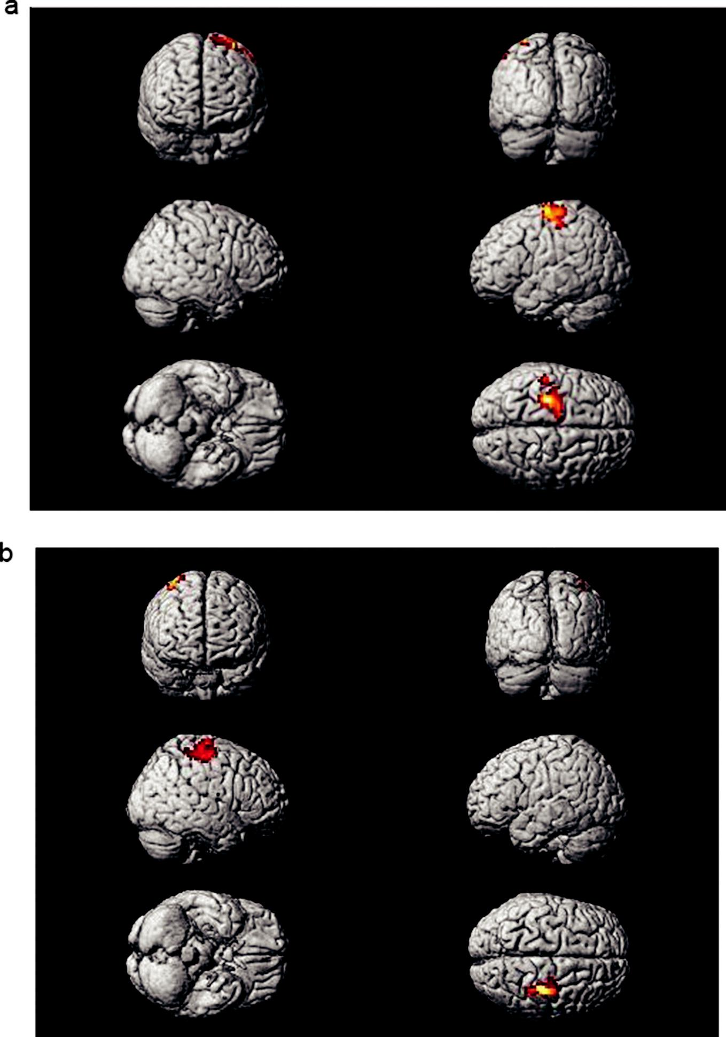

Figure 3 shows the global motor cortex activa-tion map of the healthy control (HC) group. 3A: The right primary sensory-motor cortex (S1M1) was activated during the right-hand grip task. 3B: The left S1M1 was activated during the left -hand grip task.

Figure 3. The global motor cortex activation map of the healthy control (HC) group.

Table 5 shows the statistical information of the HC group, as analyzed by a t test with xjview processing software, and the coordinates of the most highly activated voxel (MiNi coordinates) and activation intensities (T scores) are listed by activated areas (p < .05, FWR; Ke ≥ 10).

3.2 Left hemisphere stroke group (group A)

During the entire three-month observation period, clenching the right hand (paretic hand) movement produced activation in the expected sensorimotor network. During the first session, the motor task activated the bilateral S1M1 and right premotor cortex (PMC) areas, and the total activation area

TOPICS IN STROKE REHABILITATION | 7

included 197.00 ± 13.06 voxels in the left hemi-sphere motor cortex and 124.17 ± 14.40 voxels in the right hemisphere motor cortex. During session 2, paretic hand movements activated the bilateral S1M1, right supplementary motor area (SMA), and left PMC, and the total activation area included 152.00 ± 14.84 voxels in the left hemisphere motor cortex and 68.67 ± 13.23 voxels in the right hemisphere motor cortex. During session 3, paretic hand movements activated only the left S1M1 and the total activation area included 101.17 ± 15.45 voxels (Table 6 and Figure 4).

Figure 4 shows the dynamic global motor cortex activation map with right-hand (paretic hand) movements in the left hemisphere stroke group.

Table 6. MINI coordinates and T scores of the activated areas during right-hand (paretic) movements in the left hemisphere stroke group in different periods.

 | T1(Session 1) |  | T2(Session 2) |  | T3(Session 3)
 | x, y, z | T value | x, y, z | T value | x, y, z | T value
S1M1_{a} | 12, −30, 81 | 9.43 | 24, −27, 78 | 7.07
S1M1_{b} | −30, −30, 69 | 7.72 | −35, −18, 63 | 11.33 | −36, −27, 66 | 13.77
SMA_{a} |  |  | 6, −6, 54 | 5.75
PMC_{a} | 63, −27, 24 | 6.11
PMC_{b} |  |  | −18, 66, −6 | 4.84

Note: A: Ipsilateral brain regions relative to the moving hand
b: Contralateral brain regions relative to the moving hand
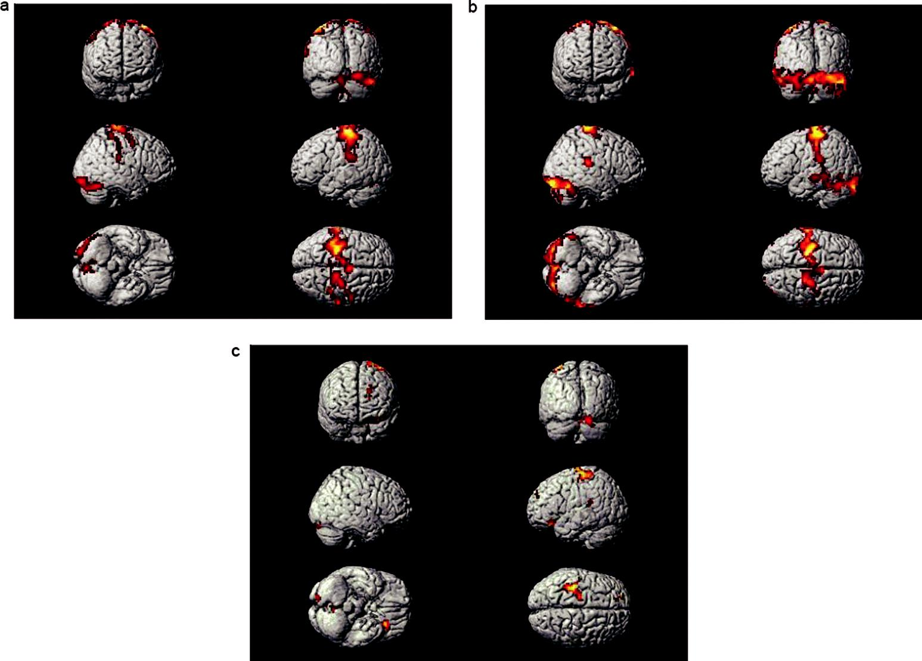

Figure 4. The dynamic global motor cortex activation map with right-hand (paretic hand) movements in the left hemisphere stroke group.

8 L. CHUNYONG ET AL.

3A shows that the bilateral S1M1 and right PMC were activated during paretic hand movements during the first session (acute stage). 4B shows that the bilateral S1M1, right SMA, and left PMC were activated during paretic hand movements during session 2 (early subacute stage). 4C shows that only the left S1M1 was activated during paretic hand movements during session 3 (late subacute stage).

Table 6 shows the statistical information of the left hemisphere stroke group, as analyzed by a t test with xjview processing software, and the coordinates of the most highly activated voxel (MINI coordinates) and activation intensi-ties (T scores) are listed by activated areas (p < .05, FWR; Ke ≥ 10).

shows that the bilateral S1M1, right PMC, and right SMA were activated during paretic hand movements during the first session (acute stage). 5B shows that the bilateral S1M1, right SMA, and right PMC were activated during paretic hand movements during session 2 (early subacute stage).5C shows that only the right S1M1 was acti-vated during paretic hand movements during ses-sion 3 (late subacute stage).

Table 7 shows the statistical information of the left hemisphere stroke group, as analyzed by a t test with xjview processing software, and the coordinates of the most highly activated voxel (MINI coordinates) and activation intensi-ties (T scores) are listed by activated areas (p < .05, FWR; Ke ≥ 10).

3.3 Right hemisphere stroke group (group B)

Clenching the left hand (paretic hand) inacti-vated the expected sensorimotor network. During the first session, the motor task activated the bilateral S1M1, right PMC and SMA, and the total activation areas included 61.00 ± 12.67 vox-els in the left hemisphere motor cortex and 105.60 ± 14.66 voxels in the right hemisphere motor cortex. During session 2, paretic hand movements activated the bilateral S1M1, right PMC and SMA, and the total activation areas included 34.90 ± 10.64 voxels in the left hemi-sphere motor cortex and 83.70 ± 10.11 voxels in the right hemisphere motor cortex. During ses-sion 3, paretic hand movements activated only the right S1M1, and the total activation area included 96.80 ± 11.17 voxels (Table 7 and Figure 5).

Figure 5 shows the dynamic global motor cortex activation map with left-hand (paretic hand) move-ment in the right hemisphere stroke group. 5A

3.4 Dominant hemisphere infarction vs.

nondominant hemisphere infarction

While comparing the differences in cortical activa-tion across the three fMRI sessions, we found dif-ferences between the conditions of the dominant hemisphere affected and the dominant hemisphere unaffected. During session 1 and session 2, the activation of voxels by paretic hand movements was greater in the dominant hemisphere (impaired hemisphere) in the left hemisphere stroke group than in the nondominant hemisphere (impaired hemisphere) in the right hemisphere stroke group. The activation of voxels by paretic hand move-ments was also greater in the nondominant hemi-sphere (unimpaired hemisphere) in the left hemisphere stroke group than in the dominant hemisphere (unimpaired hemisphere) in the right hemisphere stroke group. During session 3, there were no differences between the groups (Table 6, Table 7, and Figure 6).

Table 7. MINI coordinates and T scores of the activated areas during left-hand (paretic) movements in the right hemisphere stroke group in different periods.

 | T1(Session 1) |  | T2(Session 2) |  | T3(Session 3)
 | x, y, z | T value | x, y, z | T value | x, y, z | T value
S1M1_{a} | −45, −33, 66 | 7.25 | −24, −42, 69 | 5.75
S1M1_{b} | 39, −24, 66 | 8.95 | 36, −27, 69 | 9.91 | 42, −39, 63 | 9.94
SMA_{b} | 27, −18, 60 | 3.7 | 12, 30, 48 | 4.17
PMC_{b} | 8, 3, 68 | 4.8 | 9, 0, 75 | 5.99

Note: A: Ipsilateral brain regions relative to the moving hand
b: Contralateral brain regions relative to the moving hand

TOPICS IN STROKE REHABILITATION | 9
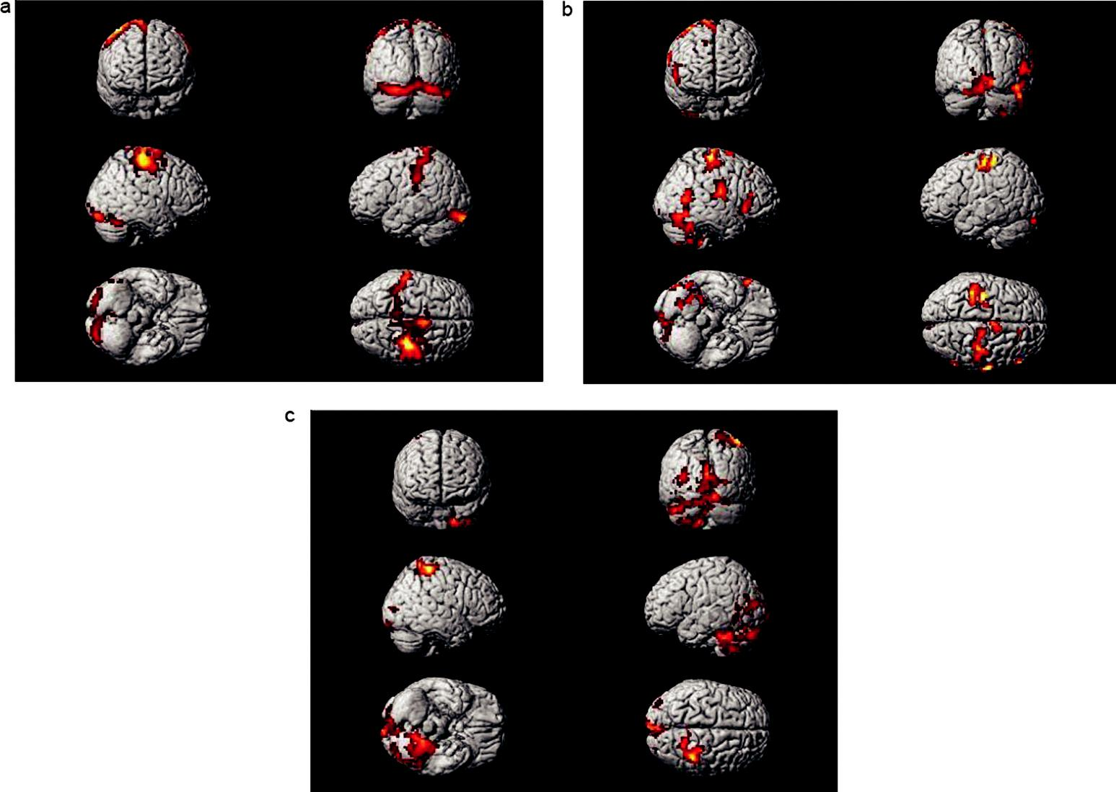

Figure 5. The dynamic global motor cortex activation map with left-hand (paretic hand) movement in the right hemisphere stroke group.

3.5 Correlations between behavioral assessments and fMRI

There was a negative correlation between the values in the affected finger-tapping test and voxels in ipsilateral hemisphere activation in the left hemisphere infarction group. Similar correla-tions were found with the right hemisphere infarc-tion group. As finger tapping increased voxel activity decreased ipsilaterally. In addition, a positive correlation was noted for contralateral hemisphere activation in the left hemisphere infarc-tion group. Similar correlations were found with the right hemisphere infarction group (Table 8).

4. Discussion

4.1. Cortical reorganization patterns

In our study, during the early stages of stroke (acute stage), the patients’ paralytic hand move-ments activated the bilateral S1M1, contralateral PMC and SMA. In the HC group, hand move-ments activated only the contralateral S1M1 and PMC. These differences suggest that the unaf-fected hemisphere plays an important role in

compensating for the impaired motor function of the paralytic hand during the early stage after stroke. Using positron emission tomography-computed tomography (PET-CT), Calautti et al⁸ found that during the early stages of stroke, paralytic hand movements activated the hand areas of the cerebral cortex and the whole-brain motor network. Using fMRI, Marshall et al⁹ revealed that stroke patients showed greater acti-vation in the ipsilateral SMA, ipsilateral posterior parietal region, and bilateral prefrontal regions than the controls during a finger-thumb opposi-tion task. In our study, as the function of the paretic hand recovered during the early subacute stage of stroke, motor cortex activation in the contralesional hemisphere (unaffected hemi-sphere) decreased, while that in the ipsilesional hemisphere (affected hemisphere) increased. It can be inferred that the dominant role of the affected hemisphere in the motor task gradually increased during the recovery of function in the paretic hand, while the compensatory role of the unaffected hemisphere gradually decreased. Rehme et al¹⁰ found that patients with poorer outcomes showed enhanced negative coupling

10 L. CHUNYONG ET AL.
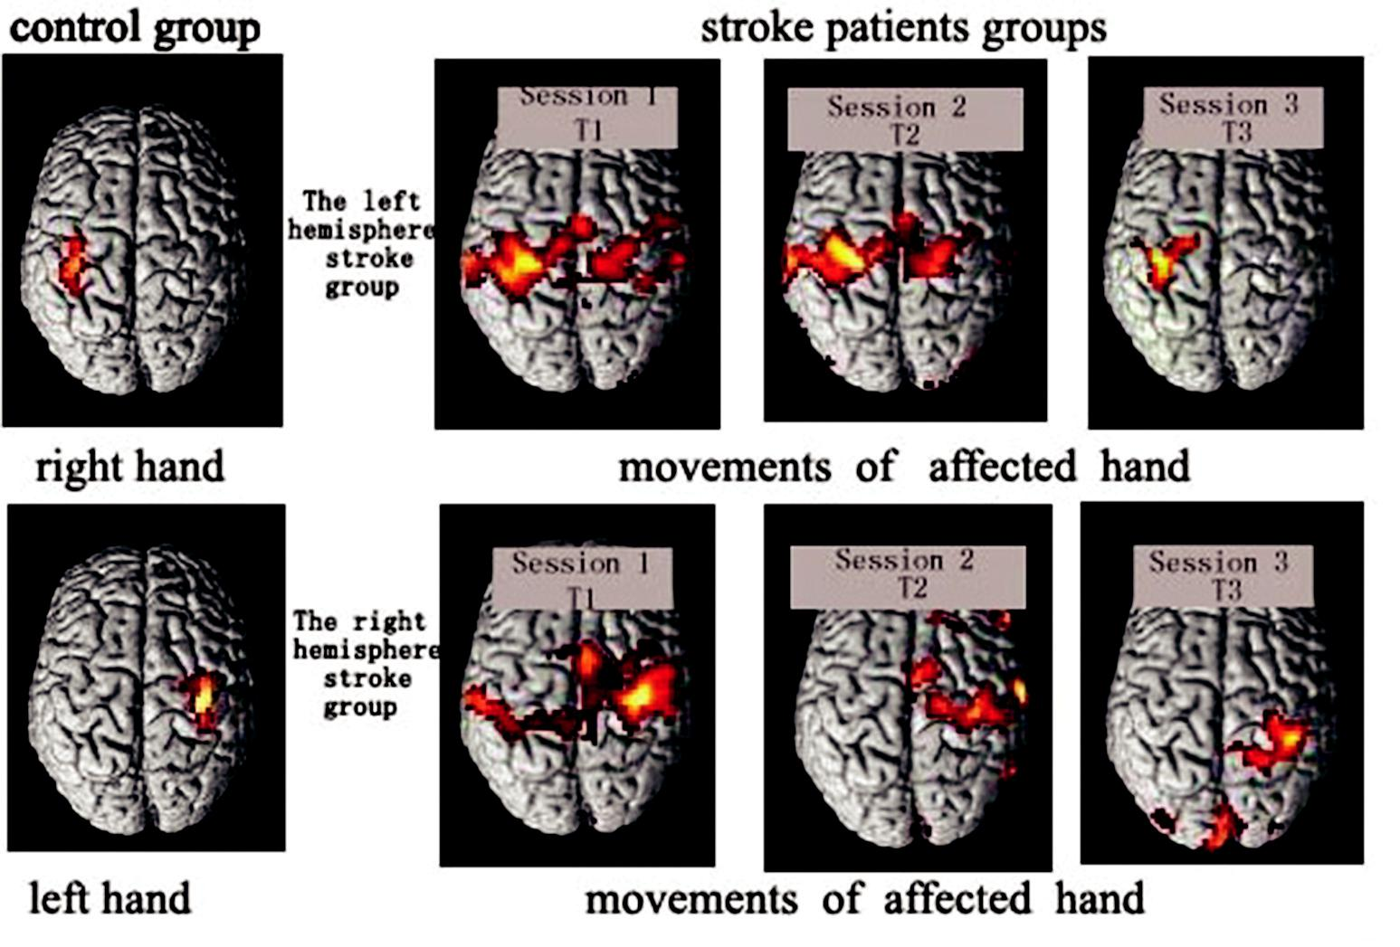

Figure 6. The left panels show activation in the HC group; the top left panel shows that the left S1M1 was activated by right-hand movements, while the bottom left panel shows that the right S1M1 was activated by left-hand movements. The top right panel shows the dynamic process of motor cortex activation in the left hemisphere stroke group during right-hand movements. The bottom right panel shows the dynamic process of motor cortex activation in the right hemisphere stroke group during left-hand movements. During the acute stage, the activated voxels in the dominant hemisphere in the left hemisphere stroke group were greater than those in the nondominant hemisphere stroke group during the paretic hand grip task. During the early subacute stage, the tendency persisted, and the activated voxels in the nondominant hemisphere in the left hemisphere stroke group were greater than those in the dominant hemisphere in the right hemisphere stroke group during the paretic hand grip task. During the late subacute stage, the two groups showed no differences.

Table 8. Correlations between finger-tapping test and fMRI.

 | Right hand (A) |  |  | Left hand (B) |  |  | Right hand (A) |  |  | Left hand (B)
 | T2-T1 | T3-T2 |  | T2-T1 T3-T2 |  |  | T2-T1 T3-T2 |  |  | T2-T1 T3-T2
r | −0.855 | −0.845 | 0.815 |  | 0.811 | 0.796 |  | −0.763 | 0.647 |  | 0.682
P | 0.03 | 0.034 | 0.048 |  | 0.05 | 0.01 |  | 0.017 | 0.043 |  | 0.03

Note: A-Group A (left hemisphere stroke group);

B-Group B (right hemisphere stroke group); T1: Session 1; T2: Session 2;

T3: Session 3.

from contralesional to ipsilesional M1, while patients with motor improvements showed increases in ipsilesional SMA–M1 coupling up to the late subacute stage of stroke. In our study, as the function of the paretic hand greatly recovered during the late subacute stage, paretic hand execution in the grip task showed activation of the ipsilesional S1M1 but not the contrale-sional S1M1 during fMRI. The activation patterns were similar to those in the HC group and some previous research.^{11–13}

The dynamic processes in motor cortical activa-tion were quite clear; bilateral S1M1 areas were acti-vated and increased during the acute stage after

stroke, bilateral S1M1 areas were also activated and increased, while contralesional S1M1 activation was weakened during the early subacute stage, and only the ipsilesional S1M1 was activated during the late subacute stage. The results of longitudinal fMRI stu-dies involving humans and rats have shown that neural activity in the ipsilesional sensorimotor cortex recovered, whereas abnormal activity in contrale-sional sensorimotor areas decreased concomitant with behavioral improvements.^{14–18}

4.2. What role does the unaffected hemisphere play in the process of brain reorganization?

To date, the role of the ipsilateral, unaffected hemi-sphere in recovering after stroke remains contro-versial. In some previous fMRI studies, increased task-related activation within contralesional motor structures was observed in stroke patients com-pared with healthy participants.^{19,20} These findings were generally interpreted in favor of a functional role of the ipsilateral hemisphere in recovery.

However, this interpretation has been challenged by subsequent studies reporting a persistence of these enhanced activation patterns in patients with poor recovery, and a decreased recruitment of ipsilateral motor structures in patients with improvements in motor function during follow-up.^{21,22} Several transcranial magnetic stimulation (TMS) experiments have indicated that contrale-sional brain activation may inhibit the ipsilesional cortex and thus be detrimental for motor recovery.^{23,24} Our finding of a correlation between overactivation in the unaffected hemisphere motor cortex and greater recovery in patients during the late subacute stage after stroke does not support the hypothesis that the recruitment of these structures generally represents maladaptive plasticity. Furthermore, a recent study used fMRI to investi-gate short-term reorganization in the right PMC after TMS disrupted the left PMC in healthy participants.²⁴ There was a compensatory increase in activity in the right PMC and connected medial premotor areas, demonstrating recovery of func-tion after disruption by TMS.²⁵ Gerloff et al²⁶ found that contralesional motor areas significantly contributed to motor performance by using a multimodal approach incorporating electroence-phalography (EEG), PET and TMS in patients with subcortical stroke.

Our findings were also supported by the clinical observation that patients suffering from a second stroke in the opposite hemisphere not only develop new contralateral hemiparesis but also experience impairment in the function of the recovered limb.^{27–29} The results of animal experi-ments suggest that stimulation-evoked responses in the contralesional hemisphere relatively early after stroke are related to unmasking potentiation within the present neuronal circuitry because the formation of new anatomic connections requires several days to develop and peaks weeks after stroke.³⁰ We hypothesize that the contralesional hemisphere plays a supportive role in recovery through the preexisting inhibitory network, which can be explained by our dynamic cortical reorganization model. Notably, activation in the ipsilateral SMA is not confined to stroke victims and can also be found in healthy participants during the performance of complex and nondo-minant hand tasks.^{31,32} Therefore, it is conceivable

TOPICS IN STROKE REHABILITATION | 11

that the execution of the motor tasks required the recruitment of this bilateral network during the acute and early subacute stages in our stroke patients, who were physiologically engaged with complex tasks.

4.3. What role does the dominant hemisphere play in brain functional reorganization?

Our results show that the improvements in the behavior assessments (including finger-tapping test performance and maximal hand grip strength) in the left hemisphere infarction group were less significant than those in the right hemisphere infarction group. Motor cortex activation in the paretic hand task showed differences between the left hemisphere infarction group and the right hemisphere infarction group. During the acute and early subacute stages, the evoked activation of voxels in the ipsilesional or contralesional hemisphere in the right hemisphere infarction group was less than that in the left hemisphere infarction group. Our hypothesis explains that the dominant hemisphere plays a more important role in recovery. When the dominant hemisphere is affected, recovery is more complicated, and the compensation based on bilateral activation is more extensive and longer lasting. It has been reported that individuals with a left hemisphere stroke showed slower reaction times and less accuracy when reaching their nonparetic arm than healthy participants.^{33,34} The results from healthy adults and the nonparetic limbs of stroke survivors in this study also support the idea that the left hemisphere is more involved in compiling motor tasks and implementing movements than the right hemisphere in right-hand dominant individuals. We believe that the dominant hemi-sphere plays a more important role in motor cor-tex functional reorganization than the nondominant hemisphere in the process of recov-ery after stroke.

5. Conclusion

Our results clearly demonstrate the dynamic pro-cess of motor cortical reorganization. explains the acute stages after stroke, the bilateral motor cortex was activated by paretic hand movement. The

12 L. CHUNYONG ET AL.

bilateral hemisphere was activated and there was greater activation in the contralateral cortex than the ipsilateral hemisphere. Contralateral activation was observed during the late subacute stage. The dominant hemisphere may play a more important role in the reorganization of motor recovery than the nondominant hemisphere. However, this study has some limitations because of the sample size. The dynamic process of motor cortical reorganiza-tion requires further investigation in larger samples and randomized controlled trials.

Acknowledgments

We would like to thank Dr. Wang Jun (Department of MRI Center, General Hospital of Southern Theatre Command, PLA) for helping with technology and experi-mental equipment. All financial support was provided by grants from the Natural Science Foundation of China (no. 81471172).

Disclosure statement

No potential conflict of interest was reported by the author(s).

Funding

This work was supported by the National Natural Science Foundation of China (NSFC) [81471172].

ORCID

Yan Liu http://orcid.org/0000-0002-8516-8165

References

- Raghavan P. Upper Limb Motor Impairment After Stroke[J]. Physical Medicine and Rehabilitation Clinics of North America. 2015;26(4):599–610. doi:10.1016/j. pmr.2015.06.008.

- Daly JJ, Ruff RL. Construction of efficacious gait and upper limb functional interventions based on brain plasticity evidence and model-based measures for stroke patients. Sci World J. 2007;7:2031–2045. doi:10.1100/ tsw.2007.299.

- Cramer SC. Repairing the human brain after stroke: i. Mechanisms of spontaneous recovery. Ann Neurol. 2008;63(3):272–287. doi:10.1002/ana.21393.
- Hara Y. Brain plasticity and rehabilitation in stroke patients. J Nippon Med Sch. 2015;82(1):4–13. doi:10.1272/ jnms.82.4.

- Bütefisch CM. Plasticity in the human cerebral cortex: lessons from the normal brain and from stroke. Neuroscientist. 2004;10(2):163–173. doi:10.1177/ 1073858403262152.
- Sang-Bae K, Yoon B-W. Mechanisms of functional recovery after stroke J . Front Neurol Neurosci. 2013;32:1–8.

- Li C, Liu F, Peng H, et al. The positive effect of venlafaxine on central motor conduction J . Clin Neurol Neurosurg. 2018;167:65–69. doi:10.1016/j.clineuro.2018.02.017.
- Calautti C, Leroy F, Guincestre J-Y, et al. Dynamics of motor network overactivation after striatocapsular stroke: a longitudinal PET study using a fixed-performance para-digm J . Stroke. 2001;32(11):2534–2542. doi:10.1161/ hs1101.097401.

- Marshall RS, Perera GM, Lazar RM, et al. Evolution of Cortical Activation During Recovery From Corticospinal Tract Infarction. Stroke. 2000;31(3):656–661. doi:10.1161/ 01.STR.31.3.656.
- Rehme AK, Eickhoff SB, Wang LE, et al. Dynamic causal modeling of cortical activity from the acute to the chronic stage after stroke J . Neuroimage. 2011;55(3):1147– 1158. doi:10.1016/j.neuroimage.2011.01.014.
- Ward NS, Brown MM, Thompson AJ, et al. The influ-ence of time after stroke on brain activations during a motor task J . Ann Neurol. 2004;55(6):829–834. doi:10.1002/ana.20099.

- Carey JR, Kimberley TJ, Lewis SM, et al. Analysis of fMRI and finger tracking training in subjects with chronic stroke J . Brain. 2002;125:773–788. doi:10.1093/brain/ awf091.

- Ward NS, Brown MM, Thompson AJ, et al. Neural corre-lates of motor recovery after stroke: a longitudinal fMRI study J . Brain. 2003;126:2476–2496. doi:10.1093/ brain/awg245.

- Dijkhuizen RM, Singhal AB, Mandeville JB, et al. Correlation between brain reorganization, ischemic damage, and neurologic status after transient focal cer-ebral ischemia in rats: a functional magnetic resonance imaging study J . J Neurosci. 2003;23(2):510–517. doi:10.1523/JNEUROSCI.23-02-00510.2003.

- Loubinoux I, Carel C, Pariente J . Correlation between cerebral reorganization and motor recovery after subcor-tical infarcts J . Neuroimage. 2003;20(4):2166–2180. doi:10.1016/j.neuroimage.2003.08.017.

- Mushiake H, Shima K. Functional Parcellation of Frontal Higher Order Motor Cortex J . Brain Nerve. 2016;68 (11):1271–1282. doi:10.11477/mf.1416200591.

- Weber R, Ramos-Cabrer P, Justicia C, et al. Early predic-tion of functional recovery after experimental stroke: func-tional magnetic resonance imaging, electrophysiology, and behavioral testing in rats J . J Neurosci. 2008 30;28
(5):1022–1029. doi:10.1523/JNEUROSCI.4147-07.2008.

- Rossini PM, Dal Forno G. Integrated technology for evaluation of brain function and neural plasticity
J . Phys Med Rehabil Clin N Am. 2004;15

(1):263–306. doi:10.1016/s1047-9651(03)00124-4.

- Grefkes C, Fink GR. Disruption of motor network con-nectivity post-stroke and its noninvasive neuromodula-tion J . Curr Opin Neurol. 2012;25(6):670–675. doi:10.1097/WCO.0b013e3283598473.

- Johansen-Berg H, Rushworth MF, Bogdanovic MD, et al. The role of ipsilateral premotor cortex in hand movement after stroke J . Proc Natl Acad Sci U S A. 2002 29;99(22):14518–14523. doi:10.1073/pnas.22253 6799.

- Stockert A, Wawrzyniak M, Klingbeil J, et al. Dynamics of language reorganization after left temporo-parietal and frontal stroke J . Brain. 2020;143(3):844–861. doi:10.1093/brain/awaa023.
- Duque J, Hummel F, Celnik P, et al. Transcallosal inhibition in chronic subcortical stroke J . Neuroimage. 2005;28
(4):940–946. doi:10.1016/j.neuroimage.2005.06.033.

- Murase N, Duque J, Mazzocchio R, et al. Influence of interhemispheric interactions on motor function in chronic stroke J . Ann Neurol. 2004;55(3):400–409. doi:10.1002/ana.10848.
- O’Shea J, Johansen-Berg H, Trief D, Göbel S, Rushworth MFS. Trief D, et al.Functionally specific reor-ganization in human premotor cortex J . Neuron. 2007;54(3):479–490. doi:10.1016/j.neuron.2007.04.021.

- Belardinelli P, Laer L, Ortiz E, et al. Plasticity of premotor cortico-muscular coherence in severely impaired stroke patients with hand paralysis J . Neuroimage Clin. 2017;14:726–733. doi:10.1016/j. nicl.2017.03.005.

- Ago T, Kitazono T, Ooboshi H, et al. Deterioration of pre-existing hemiparesis brought about by subsequent ipsilat-eral lacunar infarction J . J Neurol Neurosurg Psychiatry. 2003;74(8):1152–1153. doi:10.1136/jnnp.74.8. 1152.

TOPICS IN STROKE REHABILITATION | 13

- Fisher CM. Concerning the mechanism of recovery in stroke hemiplegia J . Case Rep Can J Neurol Sci. 1992;19(1):57–63. doi:10.1017/S0317167100042542.

- Song YM, Lee JY, Park JM, et al. Ipsilateral hemiparesis caused by a corona radiata infarct after a previous stroke on the opposite side J . Case Rep Arch Neurol. 2005;62(5):809–811. doi:10.1001/archneur.62.5.809.

- Lake EMR, Bazzigaluppi P, Mester J, et al. Neurovascular unit remodeling in the subacute stage of stroke recovery J . Neuroimage. 2017;146:869–882. doi:10.1016/j. neuroimage.2016.09.016.

- Mohammed H, Hollis ER. Cortical Reorganization of Sensorimotor Systems and the Role of Intracortical Circuits After Spinal Cord Injury J . Neurothe rapeutics. 2018;15(3):588–603. doi:10.1007/s13311-018-0638-z.

- Hummel F, Kirsammer R, Gerloff C. Ipsilateral cortical activation during finger sequences of increasing complex-ity: representation of movement difficulty or memory load? J . Clin Neurophysiol. 2003;114(4):605–613. doi:10.1016/S1388-2457(02)00417-0.

- Haaland KY, Harrington DL. Hemispheric control of the initial and corrective components of aiming move-ments J . Neuropsychologia. 1989;27(7):961–969. doi:10.1016/0028-3932(89)90071-7.
- Haaland KY, Prestopnik JL, Knight RT, et al. Hemispheric asymmetries for kinematic and positional aspects of reaching J . Brain. 2004;127:1145–1158. doi:10.1093/brain/awh133.

- Swayne OB, Rothwell JC, Ward NS, et al. Stages of motor output reorganization after hemispheric stroke suggested by longitudinal studies of cortical physiology J . Comp Study Cereb Cortex. 2008;18(8):1909–1922. doi:10.1093/ cercor/bhm218.

